Exercise 2 : Branching and Feature Integration

Scenario:
Your project requires two new features: an About section and a Contact form. You need to develop these features in separate branches and then merge them into the main branch.
Tasks:
- Create and switch to a new branch named about-feature.
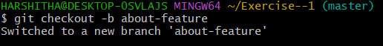
- In about-feature, add an About section with headings and text.
- Commit your changes with an appropriate message.
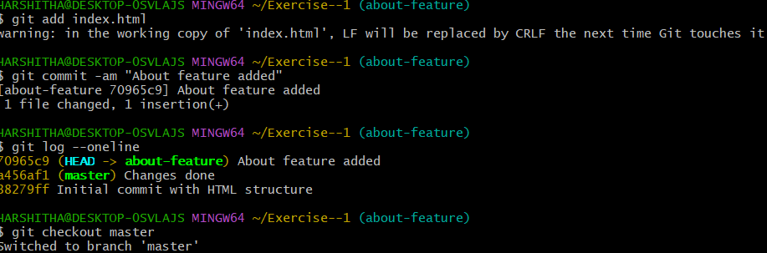
- Create another branch contact-feature from main.
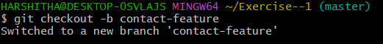
- In contact-feature, add a contact form with name, email, and message fields.
- Commit changes and merge both branches into the main branch one by one.
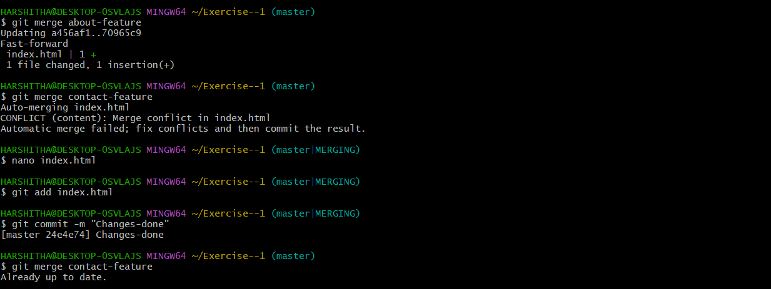
Expected Output:
• Git log showing all commits.
• Final index.html with both About and Contact sections.
